Group 6 | DESIGN AND TESTING 2

ángel delgado luna

belén garrido lópez

maría de gracia piñero pastor

ezequiel portillo jurado

alejandro rodríguez díaz

Performance Analysis

Content

Our systems 2

Use Case Test 1 2

Use Case Test 2 2

Use Case Test 3 3

Use Case Test 4 3

Use Case Test 5 4

Use Case Test 6 4

Use Case Test 7 5

Use Case Test 8 6

Use Case Test 9 6

Use Case Test 10 7

Use Case Test 11 7

Comparative Graph 8

# Our systems

|  |  |  |  |
| --- | --- | --- | --- |
|  | Alejandro’s PC | Ezequiel’s PC | Belén’s Pc |
| CPU | Intel Core i7 6700 HQ | Intel Core i7 6700 HQ | Intel Core i7 4790 |
| RAM | 12,0 GB | 16,0 GB | 16,0 GB |
| Graphic Card | NVIDIA GeForce GTX 950M | NVIDIA GeForce GTX 960M | NVIDIA GeForce GTX 960 |

# Use Case Test 1

* A non-authenticated user registers as a member. After registration he accesses his account and edits his personal data. Finally he exports his data to pdf.
* Number of threads: 100
* Loop count: 40

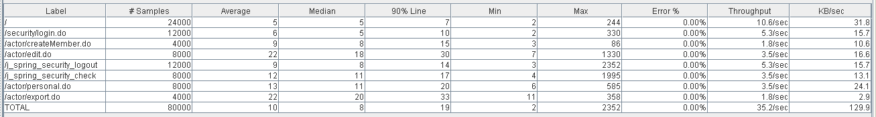

1 Aggregate report of use case 1

2 Graph results of use case 1

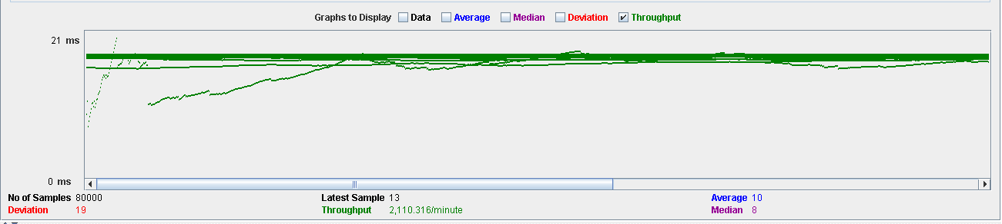

# Use Case Test 2

* A user authenticated as a student creates and edits a proclaim. Then that proclaim is assigned to a member and he accepts it. Finally as a member you can see that your proclaim has been accepted.
* Number of threads: 60
* Loop count: 40

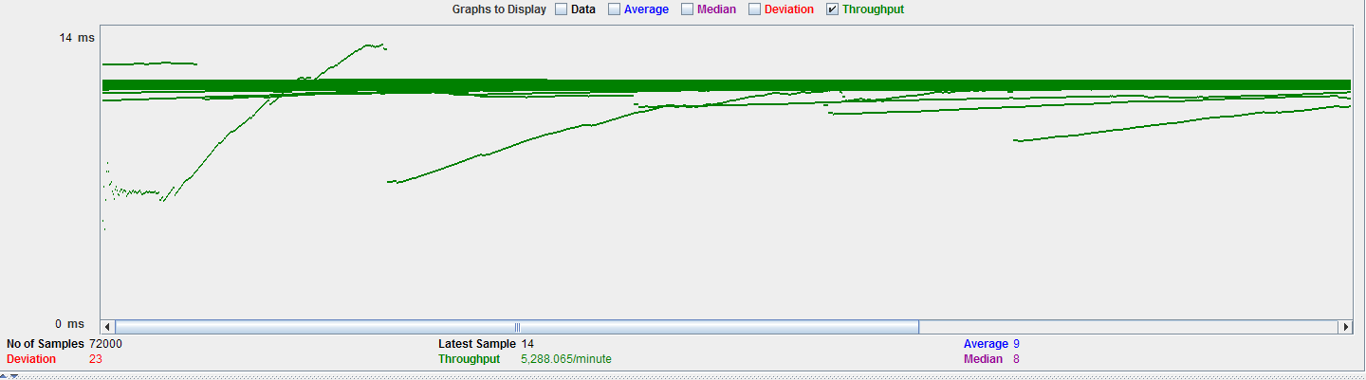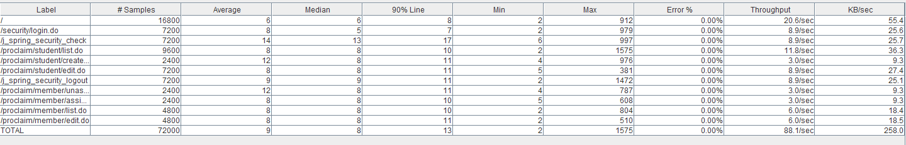

4 Graph results of use case 2

3 Aggregate report of use case 2

# Use Case Test 3

* A user authenticated as admin accesses their boxes, sends a message, displays it and sends it to the trash. Finally the other actor receives the sent message.
* Number of threads: 60
* 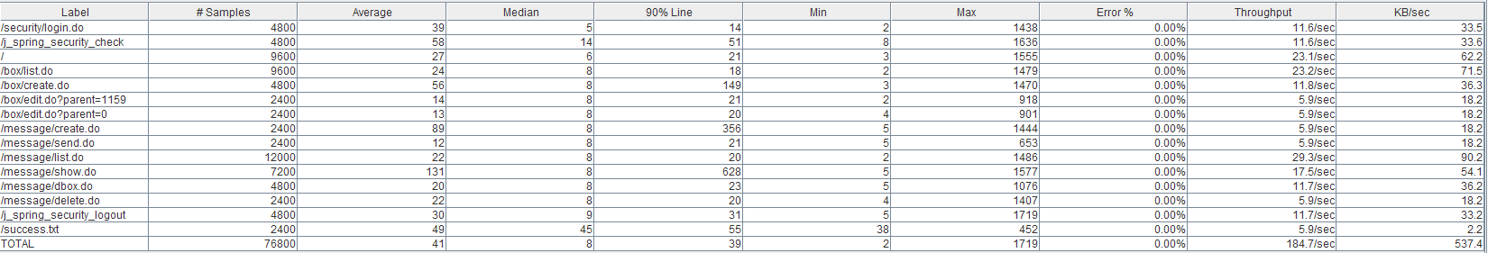Loop count: 40

5 Aggregate report of use case 3

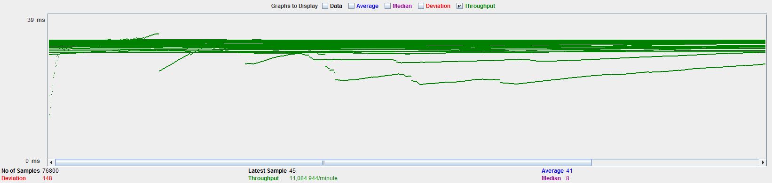

6 Graph results of use case 3

# Use Case Test 4

* A user authenticated as admin accesses the system categories. List all system categories, create a category, edit it, create it as daughter category and delete it.
* Number of threads: 140
* Loop count: 40

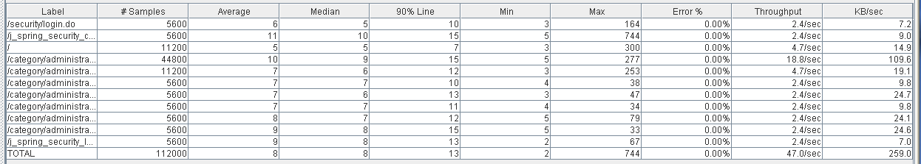

7 Aggregate report of use case 4

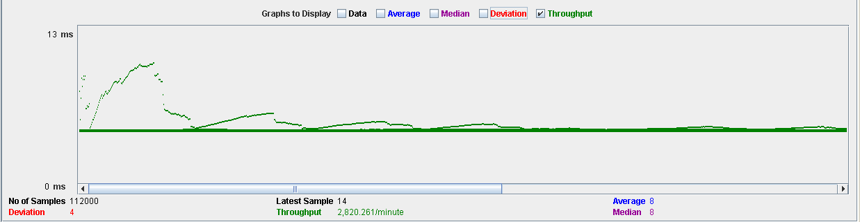

8 Graph results of use case 4

# Use Case Test 5

* A user authenticated as a member enters the system and lists the different commissions, creates one, edits it, sees it and finally deletes it.Number of threads: 50
* 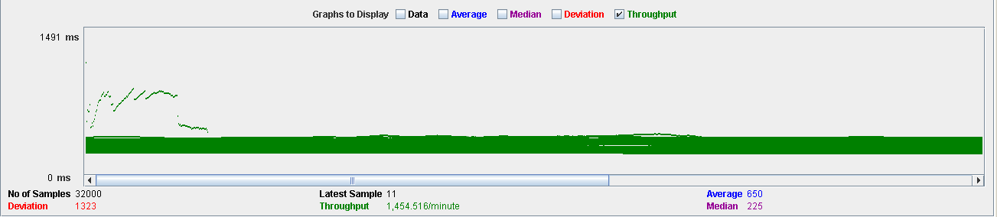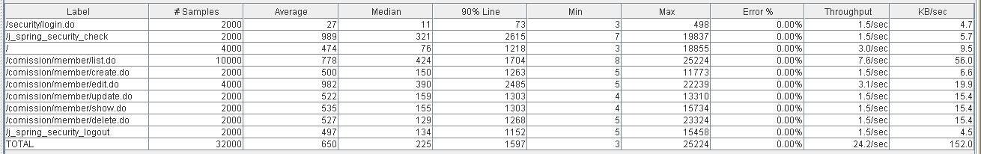Loop count: 40

9 Aggregate report of use case 5

10 Graph results of use case 5

# Use Case Test 6

* A user authenticated as admin enters the system. Changes some data of the general configuration of the system, ban an actor espamer, see the complete dasboard and the histogram of categories for proclaims.
* Number of threads: 150
* 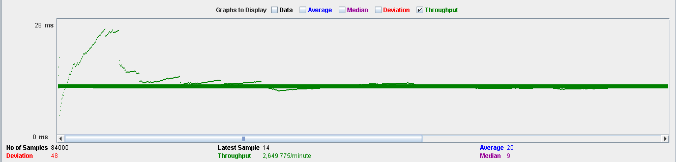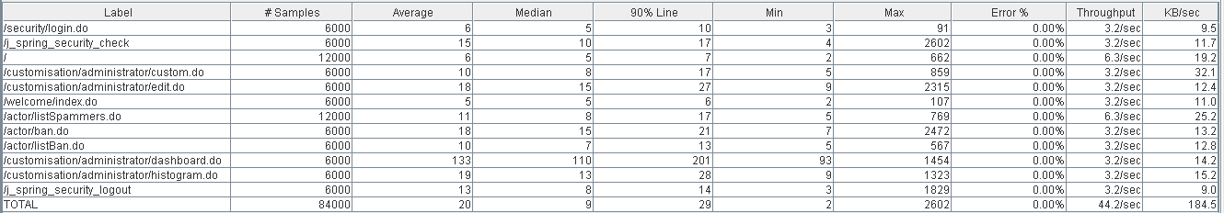Loop count: 40

12 Graph results of use case 6

11 Aggregate report of use case 6

# Use Case Test 7

* A user authenticated as a collaborator logs on to the system, where he or she can create, update, and delete different events. These will be put into final mode by the members of the system. Finally the two actors can score these events with a note.
* Number of threads: 60
* Loop count: 40

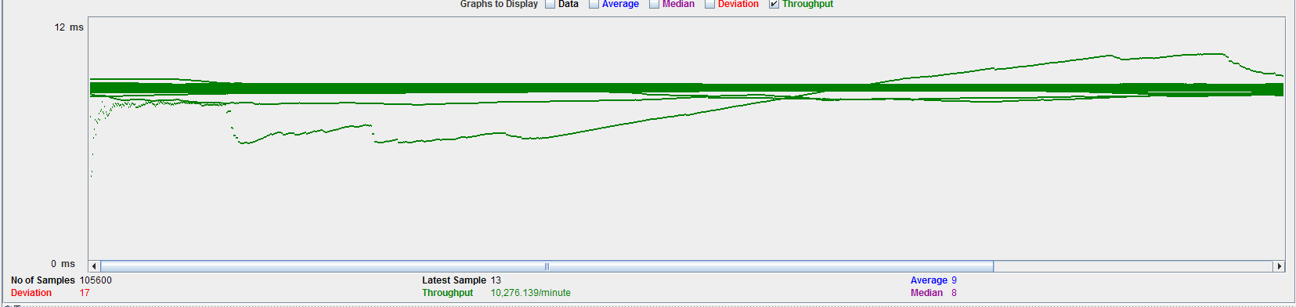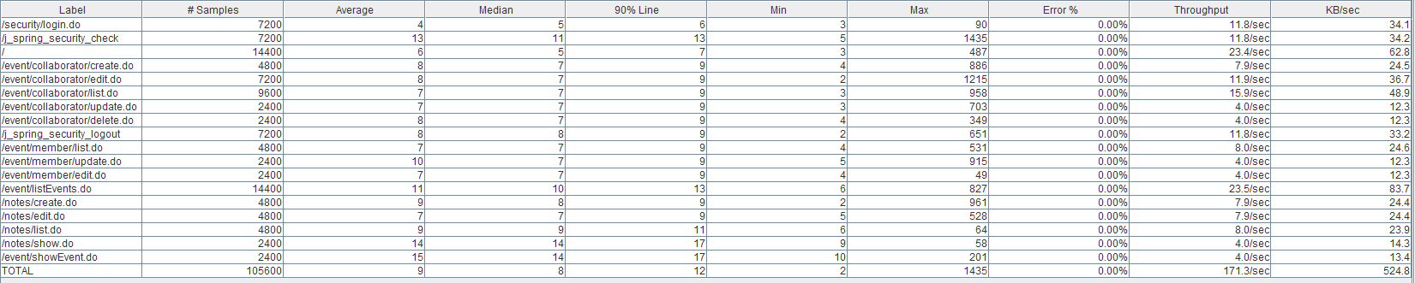

14 Graph results of use case 7

13 Aggregate report of use case 7

# Use Case Test 8

* A user authenticated as a member and can see the list of pending proclaims. The actor is assigned one of these proclaims and at the same time can filter the pending proclaims by category, name or date.
* Number of threads: 150
* Loop count: 40

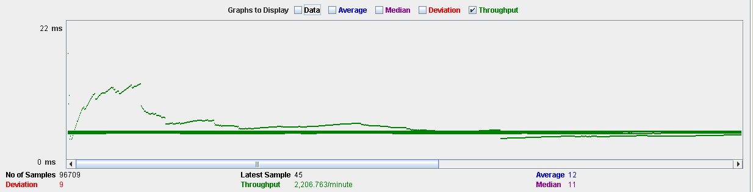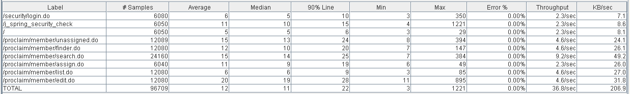

16 Graph results of use case 8

15 Aggregate report of use case 8

# Use Case Test 9

* A user authenticated as a collaborator can have a portfolio in which you can create, edit and delete different miscellaneous reports, study reports and work reports.
* Number of threads: 60
* Loop count: 40

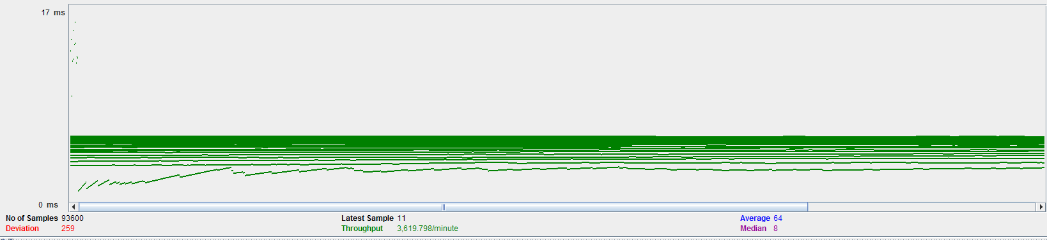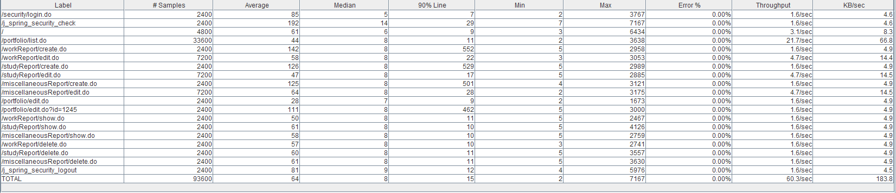

18 Graph results of use case 9

17 Aggregate report of use case 9

# Use Case Test 10

* An authenticated user asks to go to a list of your social profiles where you can create, edit, view and delete each of them.
* Number of threads: 160
* Loop count: 40

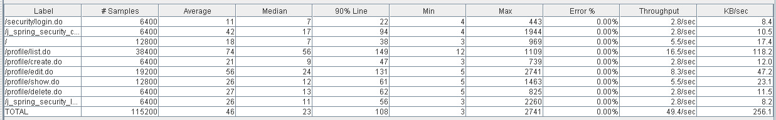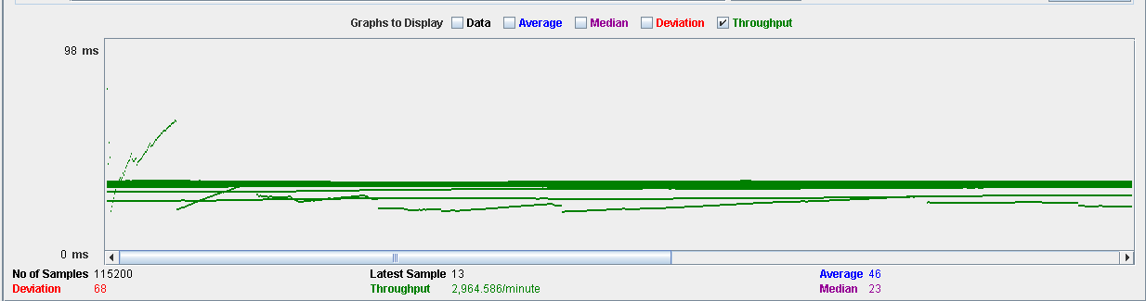

20 Graph results of use case 10

19 Aggregate report of use case 10

# Use Case Test 11

* A user authenticated as a collaborator can add you to a commission, when you are already added you can send requests for change to other actors. These requests are exchanged by the collaborators and accepted or rejected.
* Number of threads: 100
* 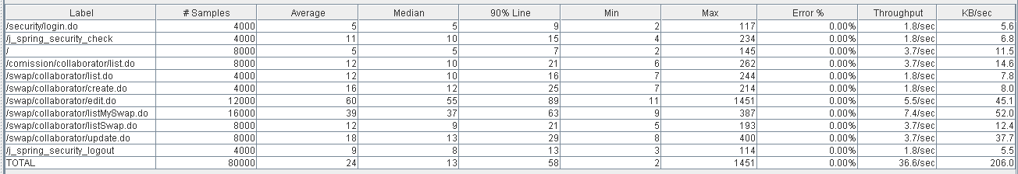Loop count: 40

21 Aggregate report of use case 11

22 Graph results of use case 11

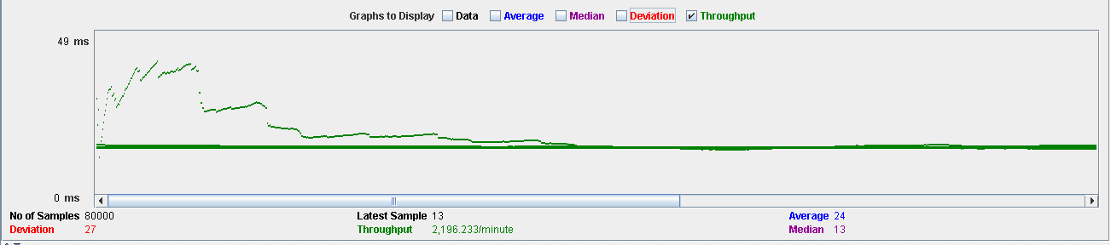

# Comparative Graph

* Following is a graph with the number of threads (users) for each use case, in a comparative in which it can be deduced that the cases of uses that has the worse performance is 5.
* Therefore, it can be ensured that the system sustains 50 users.
* 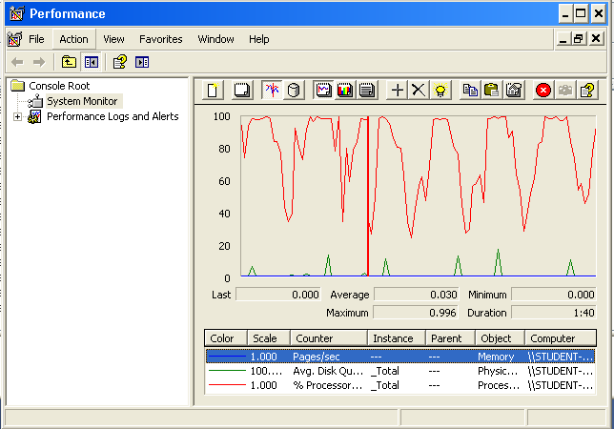To check that this is the limit, the "Performance" tool offered by Windows XP has been used and has given these results by running the performance test of the use case 5.
* We can see that the processor is at the limit of its capacity.